Program Component | Person to Contact | Contact Information
Durham PreK Management | Alex Livas-Dlott  Durham PreK Sr. Manager | durhamprek@childcareservices.org  919.403.6950 x 6829
Durham PreK Technical Assistance | Beverly Williams  TA Manager  Nita McAdoo  Lead TA Specialist  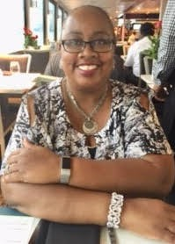  Kamika Henderson  B-K Licensure TA Specialist  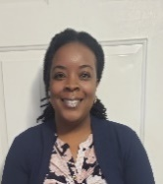  Shawn Shefte  B-K Licensure TA Specialist | beverlyw@childcareservices.org  919.403.6950 x 6855  nitam@childcareservices.org  919.403.6950 x 6865  kamikah@childcareservices.org  919.403.6950 x 6825  shawns@childcareservices.org  919.967.3272 x 1943
Durham PreK Family Engagement Counselor | Katie Thayer, Family Engagement Counselor | katiet@childcareservices.org  919.403.6950 x 6808
NC Pre-K Contact List
Durham Partnership for Children (DPfC)
Program Component | Person to Contact | Contact Information
NC Pre-K Management | Jameka Wells, Program Coordinator  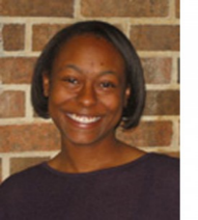 | jameka@dpfc.net  919.403.6960 x 214
NC Pre-K Technical Assistance | Taylor Young, Pre-K Quality Specialist | taylor@dpfc.net  919.403.6960 x 226
NC Pre-K and Durham PreK Family Engagement | Courtney Kelly, Family Engagement Specialist | courtney@dpfc.net  919.403.6960 x 215
NC Pre-K Outreach and NCCARE360 Specialist | Grace Smith, Outreach and NCCARE360 Specialist | grace@dpfc.net  919.403.6960 x 211
Pre-K Specialist | Melissa Radice Peguero, Pre-K Specialist  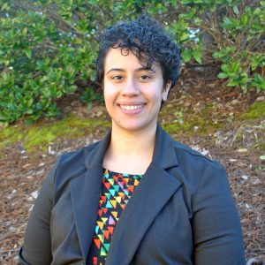 | melissa@dpfc.net  919.403.6960 x 219

